**DIS LAB6 – 4 BIT ALU**

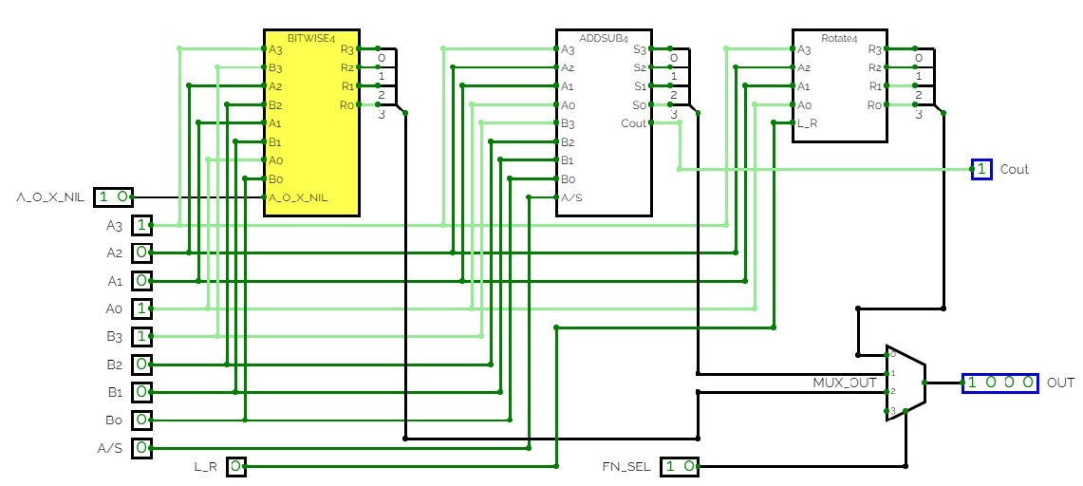

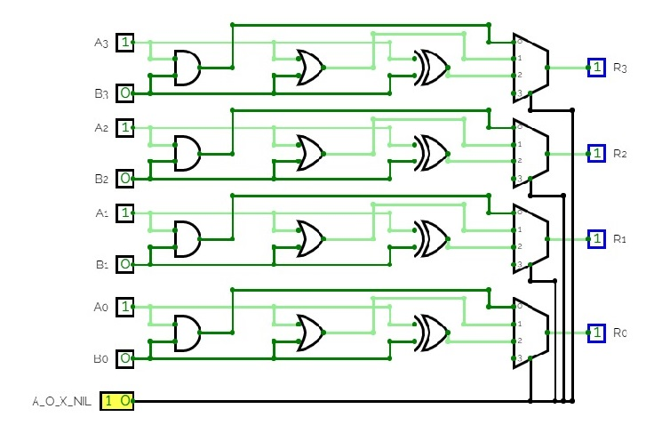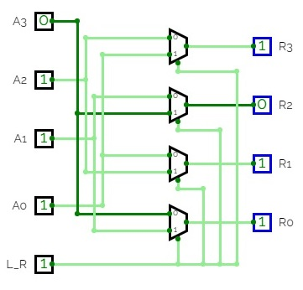

**BITWISE AND, OR, EXOR ROTATE LEFT/RIGHT**

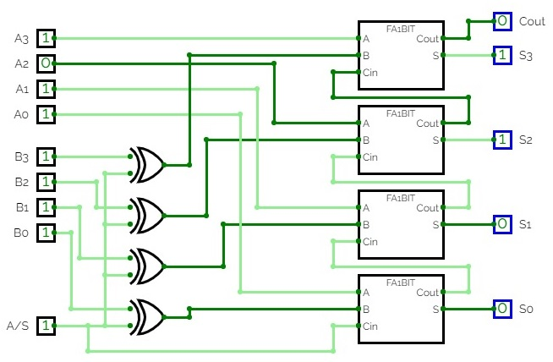

**4 BIT ADD / SUBTRACT**

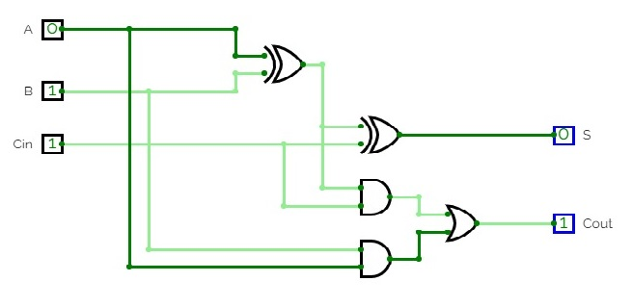

**1 BIT FULL ADDER**